Anticipating Coronary Heart Disease Risk using Deep Learning Techniques

ABSTRACT
Coronary Heart Disease (CHD) remains a leading cause of mortality worldwide, necessitating early and accurate prediction to mitigate risks. This study leverages deep learning techniques to enhance CHD prediction using the Framingham Heart Study dataset, which includes clinical and demographic risk factors such as age, blood pressure, cholesterol levels, and smoking status. We employ Artificial Neural Networks (ANN), 1D Convolutional Neural Networks (CNN-1D), and a modified U-Net architecture for prediction .
The ANN model captures complex feature interactions, while CNN-1D extracts localized patterns from sequential risk factor data. The U-Net, traditionally used for image segmentation, is adapted for 1D data to improve feature hierarchy learning. Performance are evaluated to compare models.
This study demonstrates the potential of advanced deep learning architectures in improving CHD risk stratification, showing the way for clinical decision-support systems. Future work includes integrating multimodal data and explainable AI techniques for better interpretability.
Keywords: Coronary Heart Disease, Deep Learning, ANN, CNN-1D, U-Net, Framingham Dataset, Predictive Modelling.

Tools used: - Anaconda Framework
Editor: - Jupiter Notebook
Packages Used: -Pandas, numpy, matplotlib, seaborn, Keras,Tensorflow

Contents
1.INTRODUCTION 7
1.1 What is coronary heart disease? 7
1.1.1 Causes 8
1.1.2 Risk factors 9
1.1.3 Symptoms 10
1.2 What is Deep Learning? 11
1.2.1 Application of deep learning 12
1.2.2 Types of deep Learning 12
1.3 ANN 13
Algorithms
1.3.1 Logistic regression: 16
Pros and Cons:
Multiclass Classification
1.3.2Naïve Bayes Classifier 24
What is Bayes Theorem?
Gaussian Naive Bayes
MultiNomial Naive Bayes 18
Bernoulli Naive Bayes 19
Pros and Cons of Naïve Bayes: 19
1.3.3 Decision Tree 26
1.3.4 K-Nearest Neighbor(KNN): 30
1.3.5 Support Vector Machine Algorithm 36
1.3.6 Random Forest Algorithm 36
`
1.4.1 Clustering 38
1.5 Reinforcement Learning 38
1.6 Future of Machine Learning 39
2.Problem definition and algorithm 40
2.1 Task definition 40
2.2 Heartdisease data set 40
3. Experimental set up and evaluation 42
3.1 Components to be installed: 43
3.2 Methodology 43
3.2.1 Collect the dataset: 43
3.2.2 Load the dataset: 44
3.2.3 Describe the dataset: 44
3.2.4 Heat Map 45
3.2.5 Analysis of the dataset for cleaning purpose: 47
Male and Female countplot 48
3.3 Model building 52
3.3.1 Split the dataset for training and testing: 52
3.4Train the dataset using algorithms 53
3.4.1 Using KNN Algorithm 53
3.4.2 Using Decision Tree Algorithm 54
3.4.3 Using Logistic Regression Algorithm 55
3.4.4 Using Naïve Bayes Algorithm 56
3.4.5 Using Random Forest Algorithm 57
3.4.6 Using SVM Algorithm 57

3.5 Compare the accuracy of all the Algorithm 57
3.6 Graphical Representation 58
4.Conclusion 63
5.Future Work 63

1.INTRODUCTION
The Heart is one of the most important organs in the human body. It is the centre of the circulatory system. The heart functions as a pump that propels blood to different parts of the human body through a network of blood vessels, supplying a constant supply of oxygen as well as other vital nutritional components. If the heart ever stops functioning and ceases to pump blood, the body will shut down and within very less time a person will expire.

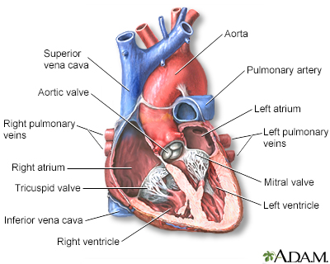
1.1 What is coronary heart disease?
Coronary heart disease (CHD) is also called as coronary artery disease. The coronary arteries are the blood vessels that carry blood to your heart. Coronary artery disease is the narrowing or blockage of the coronary arteries. This condition is usually caused by atherosclerosis. Atherosclerosis is the build-up of cholesterol and fatty deposits (called plaques) inside the arteries. These plaques can clog the arteries or damage the arteries, which limits or stops blood flow to the heart muscle.
If the heart does not get enough blood, it cannot get the oxygen and nutrients it needs to work properly. This can cause chest pain (angina) or a heart attack.
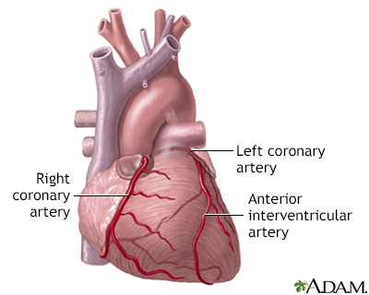
Coronary artery disease (CAD) is the most common type of heart disease in the United States. It is sometimes called ischemic heart disease.

coronary arteries supply blood to the heart muscle. The right coronary artery supplies both the left and right heart, the left coronary artery supplies the left heart.

1.1.1 Causes
Coronary artery disease is thought to begin with damage or injury to the inner layer of a coronary artery, sometimes as early as childhood. The damage may be caused by various factors, including:
- Smoking
- High blood pressure
- High cholesterol
- Diabetes or insulin resistance
- Not being active (sedentary lifestyle)
Once the inner wall of an artery is damaged, fatty deposits (plaque) made of cholesterol and other cellular waste products tend to collect at the site of injury. This process is called atherosclerosis. If the plaque surface breaks or ruptures, blood cells called platelets clump together at the site to try to repair the artery. This clump can block the artery, leading to a heart attack.
1.1.2 Symptoms
An acute coronary event, such as a heart attack, may cause the following symptoms:
- Cold sweats
- Dizziness
- Light-headedness
- Nausea or a feeling of indigestion
- Neck pain
- Shortness of breath, especially with activity
- Sleep disturbances
- Weakness
The usage of information technology in health care industry is increasing day by day to aid doctors in decision making activities. It helps doctors and physicians in disease management, medications and discovery of patterns and relationships among diagnosis data. Current approaches to predict cardiovascular risk fail to identify many people who would benefit from preventive treatment, while others receive unnecessary intervention. Machine-learning offers opportunity to improve accuracy by exploiting complex interactions between risk factors. We assessed whether machine-learning can improve cardiovascular risk prediction.

1.2 What is Deep learning?
Deep Learning (DL) is a subfield of machine learning (ML) that uses artificial neural networks (ANNs) with multiple layers (hence "deep") to model complex patterns in data. Unlike traditional ML algorithms, which require manual feature extraction, deep learning models automatically learn hierarchical representations from raw data, making them highly effective for tasks like image recognition, natural language processing (NLP), and medical diagnosis.
Deep learning has gained prominence due to:
- Increased computational power (GPUs, TPUs)
- Availability of large datasets (Big Data)
- Advancements in neural network architectures
1.2.1 Application of Deep learning
- Deep Learning (DL) has revolutionized various industries by enabling machines to learn complex patterns from vast amounts of data. Below are some key applications of deep learning, with a focus on healthcare, biomedical research, and other domains.
1. Healthcare & Medical Applications
(1) Disease Diagnosis & Prediction
- Medical Imaging Analysis
  - Radiology (X-ray, CT, MRI): Detecting tumors, fractures, and abnormalities using CNNs.
  - Ophthalmology: Diagnosing diabetic retinopathy and glaucoma from retinal scans.
  - Pathology: Identifying cancer cells in histopathology slides.
- Cardiovascular Disease Prediction
  - Predicting coronary heart disease (CHD) using patient history (ANN, CNN-1D).
  - Analyzing ECG signals with 1D-CNNs/LSTMs for arrhythmia detection.
(2) Drug Discovery & Genomics
- Molecular Property Prediction: Using Graph Neural Networks (GNNs) to predict drug interactions.
- Protein Folding: AlphaFold (DeepMind) predicts 3D protein structures.
- Personalized Medicine: Tailoring treatments based on genetic data (Deep Learning + Bioinformatics).
(3) Wearable & Remote Patient Monitoring
- Real-time Health Tracking:
  - Detecting atrial fibrillation (AFib) from smartwatch ECG data.
  - Predicting seizures in epilepsy patients using LSTM networks.
2. Computer Vision & Image Processing
- Autonomous Vehicles:
  - Object detection (YOLO, Faster R-CNN) for self-driving cars.
- Facial Recognition & Biometrics:
  - Used in security systems (e.g., Face ID).
- Satellite & Aerial Imaging:
  - Deforestation tracking, disaster response, and urban planning.

3. Natural Language Processing (NLP)
- Chatbots & Virtual Assistants:
  - GPT-4, ChatGPT, and medical chatbots for patient queries.
- Clinical Text Analysis:
  - Extracting insights from Electronic Health Records (EHRs) using BERT/Transformers.
- Automated Medical Transcription:
  - Converting doctor-patient conversations into structured notes.
4. Finance & Business
- Fraud Detection:
  - Detecting credit card fraud using Autoencoders (anomaly detection).
- Algorithmic Trading:
- Predicting stock trends with LSTMs & Reinforcement Learning (RL).
- Customer Sentiment Analysis:
- Analyzing social media/reviews using NLP models.

5. Industrial & IoT Applications
- Predictive Maintenance:
  - Detecting machinery failures using CNNs on sensor data.
- Smart Agriculture:
  - Crop disease detection from drone images.

- Customer Sentiment Analysis:
  - Analyzing social media/reviews using NLP models.
6. Emerging Applications
- Metaverse & Augmented Reality (AR):
  - DL-powered virtual avatars and real-time object recognition.
- Climate Science:
  - Weather prediction using Physics-Informed Neural Networks (PINNs).

1.2.2 Types of Deep Learning
(1) Artificial Neural Networks (ANNs)
- Basic structure: Input layer, hidden layers, and output layer.
- Used for: Regression, classification, and function approximation.
- Example: Predicting coronary heart disease (CHD) risk from structured clinical data.
(2) Convolutional Neural Networks (CNNs)
- Specialized for: Grid-like data (images, 1D signals, time-series).
- Key layers: Convolutional layers (feature extraction), pooling layers (dimensionality reduction), and fully connected layers (classification).
  - 2D-CNN: Used in image processing (e.g., X-ray, MRI analysis).
  - 1D-CNN: Processes sequential data (e.g., ECG signals, clinical time-series).
- Example: Detecting CHD from ECG signals using 1D-CNN.
(3) Recurrent Neural Networks (RNNs) & Long Short-Term Memory (LSTM)
- Designed for: Sequential/temporal data (time-series, text, speech).
- LSTM: A variant of RNN that solves the vanishing gradient problem, useful for long-term dependencies.
- Example: Predicting heart disease progression from patient history.
(4) U-Net (Originally for Image Segmentation)
- Architecture: Encoder-decoder with skip connections (preserves spatial details).
- Modified for 1D: Can be adapted for sequential medical data (e.g., predicting CHD risk).
- Example: Segmenting coronary arteries in angiograms or analyzing risk factor sequences.
(5) Autoencoders (AEs) & Variational Autoencoders (VAEs)
- Purpose: Unsupervised learning, dimensionality reduction, anomaly detection.
- Used in: Feature extraction from high-dimensional medical data.
(6) Transformer Models (e.g., BERT, Vision Transformer)
- Revolutionized NLP and image processing using self-attention mechanisms.
- Example: Analyzing electronic health records (EHR) for CHD prediction.

1.3 ANN (Artificial Neural Network)
Supervised Learning is the most popular paradigm for performing machine learning operations. It is widely used for data where there is a precise mapping between input-output data. The dataset, in this case, is labelled, meaning that the algorithm identifies the features explicitly and carries out predictions or classification accordingly. As the training period progresses, the algorithm is able to identify the relationships between the two variables such that we can predict a new outcome.
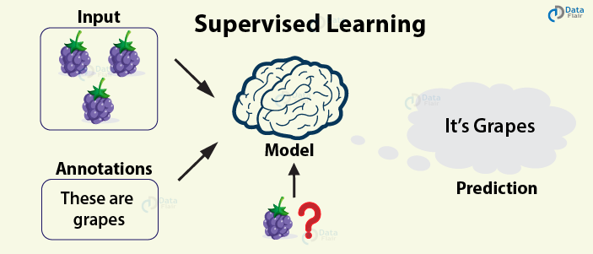
Resulting Supervised learning algorithms are task-oriented. As we provide it with more and more examples, it is able to learn more properly so that it can undertake the task and yield us the output more accurately.
Steps
In order to solve a given problem of supervised learning, one has to perform the following steps:
Determine the type of training examples. Before doing anything else, the user should decide what kind of data is to be used as a training set. In case of handwriting analysis, for example, this might be a single handwritten character, an entire handwritten word, or an entire line of handwriting.
Gather a training set. The training set needs to be representative of the real-world use of the function. Thus, a set of input objects is gathered and corresponding outputs are also gathered, either from human experts or from measurements.
Determine the input feature representation of the learned function. The accuracy of the learned function depends strongly on how the input object is represented. Typically, the input object is transformed into a feature vector, which contains a number of features that are descriptive of the object. The number of features should not be too large, because of the curse of dimensionality; but should contain enough information to accurately predict the output.
Determine the structure of the learned function and corresponding learning algorithm. For example, the engineer may choose to use support vector machines or decision trees.
Complete the design. Run the learning algorithm on the gathered training set. Some supervised learning algorithms require the user to determine certain control parameters. These parameters may be adjusted by optimizing performance on a subset (called a validation set) of the training set, or via cross-validation.
Evaluate the accuracy of the learned function. After parameter adjustment and learning, the performance of the resulting function should be measured on a test set that is separate from the training set.
Algorithm choice
A wide range of supervised learning algorithms are available, each with its strengths and weaknesses. There is no single learning algorithm that works best on all supervised learning problems (see the No free lunch theorem).
When considering a new application, the engineer can compare multiple learning algorithms and experimentally determine which one works best on the problem at hand (see cross validation). Tuning the performance of a learning algorithm can be very time-consuming. Given fixed resources, it is often better to spend more time collecting additional training data and more informative features than it is to spend extra time tuning the learning algorithms.

Algorithms
The most widely used learning algorithms are:
- Logistic regression
- Naive Bayes
- Decision trees
- K-nearest neighbor algorithm
- Support vector machine algorithm
- Random forest
Some of the algorithms that come under supervised learning are as follows

1.3.1 Logistic regression:
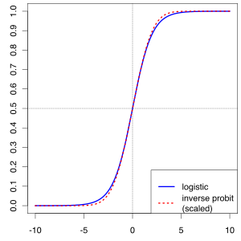

In statistics, the logistic model (or logit model) is a widely used statistical model that, in its basic form, uses a logistic function to model a binary dependent variable; many more complex extensions exist. In regression analysis, logistic regression (or logit regression) is estimating the parameters of a logistic model; it is a form of binomial regression. Mathematically, a binary logistic model has a dependent variable with two possible values, such as pass/fail, win/lose, alive/dead or healthy/sick; these are represented by an indicator variable, where the two values are labeled "0" and "1". In the logistic model, the log-odds (the logarithm of the odds) for the value labeled "1" is a linear combination of one or more independent variables ("predictors"); the independent variables can each be a binary variable (two classes, coded by an indicator variable) or a continuous variable (any real value).
The corresponding probability of the value labeled "1" can vary between 0 (certainly the value "0") and 1 (certainly the value "1"), hence the labeling; the function that converts log-odds to probability is the logistic function, hence the name. The unit of measurement for the log-odds scale is called a logit, from logistic unit, hence the alternative names.
Logistic regression was developed by statistician David Cox in 1958. The binary logistic regression model has extensions to more than two levels of the dependent variable: categorical outputs with more than two values are modeled by multinomial logistic regression, and if the multiple categories are ordered, by ordinal logistic regression, for example the proportional odds ordinal logistic model.

Applications
Logistic regression is used in various fields, including machine learning, most medical fields, and social sciences. For example, the Trauma and Injury Severity Score (TRISS), which is widely used to predict mortality in injured patients, was originally developed by Boyd et al. using logistic regression. Many other medical scales used to assess severity of a patient have been developed using logistic regression. Logistic regression may be used to predict the risk of developing a given disease (e.g. diabetes; coronary heart disease), based on observed characteristics of the patient (age, sex, body mass index, results of various blood tests, etc.). Another example might be to predict whether an Indian voter will vote BJP or Trinamool Congress or Left Front or Congress, based on age, income, sex, race, state of residence, votes in previous elections, etc. The technique can also be used in engineering, especially for predicting the probability of failure of a given process, system or product. It is also used in marketing applications such as prediction of a customer's propensity to purchase a product or halt a subscription, etc.
Logistic regression can be seen as a special case of the generalized linear model and thus analogous to linear regression. The model of logistic regression, however, is based on quite different assumptions (about the relationship between dependent and independent variables) from those of linear regression. In particular the key differences between these two models can be seen in the following two features of logistic regression. First, the conditional distribution is a Bernoulli distribution rather than a Gaussian distribution, because the dependent variable is binary. Second, the predicted values are probabilities and are therefore restricted to (0, 1) through the logistic distribution function because logistic regression predicts the probability of particular outcomes rather than the outcomes themselves.
Logistic Regression was used in the biological sciences in early twentieth century. It was then used in many social science applications. Logistic Regression is used when the dependent variable(target) is categorical
For example,
. To predict whether an email is spam (1) or (0)
. Whether the tumour is malignant (1) or not (0)
Consider a scenario where we need to classify whether an email is spam or not. If we use linear regression for this problem, there is a need for setting up a threshold based on which classification can be done. Say if the actual class is malignant, predicted continuous value 0.4 and the threshold value is 0.5, the data point will be classified as not malignant which can lead to serious consequence in real time.
From this example, it can be inferred that linear regression is not suitable for classification problem. Linear regression is unbounded, and this brings logistic regression into picture. Their value strictly ranges from 0 to 1.
Simple Logistic Regression
Model
Output = 0 or 1
Hypothesis => Z = WX + B
hΘ(x) = sigmoid (Z)
Sigmoid Function
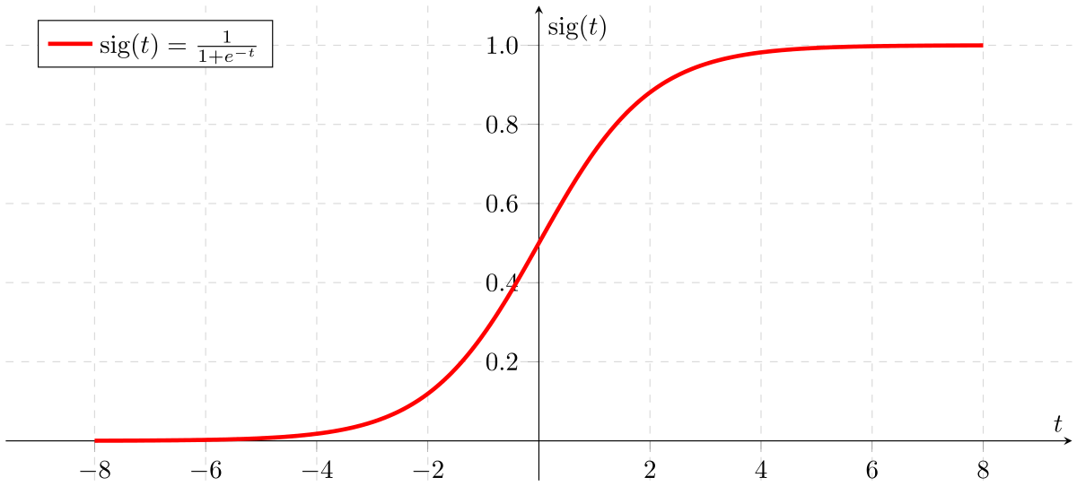
Figure 2: Sigmoid Activation Function
If ‘Z’ goes to infinity, Y(predicted) will become 1 and if ‘Z’ goes to negative infinity, Y(predicted) will become 0.
Analysis of the hypothesis
The output from the hypothesis is the estimated probability. This is used to infer how confident can predicted value be actual value when given an input X. Consider the below example,
X = [x0 x1] = [1 IP-Address]
Based on the x1 value, let’s say we obtained the estimated probability to be 0.8. This tells that there is 80% chance that an email will be spam.
Mathematically this can be written as,
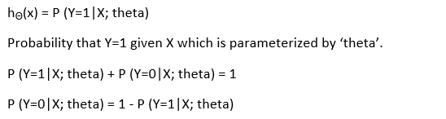
This justifies the name ‘logistic regression’. Data is fit into linear regression model, which then be acted upon by a logistic function predicting the target categorical dependent variable.

Types of Logistic Regression
1. Binary Logistic Regression
The categorical response has only two 2 possible outcomes. Example: Spam or Not
2. Multinomial Logistic Regression
Three or more categories without ordering. Example: Predicting which food is preferred more (Veg, Non-Veg, Vegan)
3. Ordinal Logistic Regression
Three or more categories with ordering.
Example: Movie rating from 1 to 5
Decision Boundary
To predict which class a data belongs, a threshold can be set. Based upon this threshold, the obtained estimated probability is classified into classes.
Say, if predicted value ≥ 0.5, then classify email as spam else as not spam.
Decision boundary can be linear or non-linear. Polynomial order can be increased to get complex decision boundary.
Cost Function
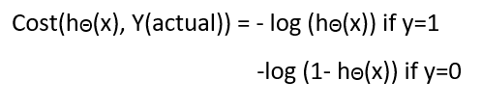
Linear regression uses mean squared error as its cost function. If this is used for logistic regression, then it will be a non-convex function of parameters (theta). Gradient descent will converge into global minimum only if the function is convex.
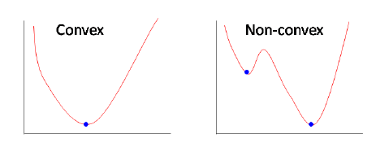
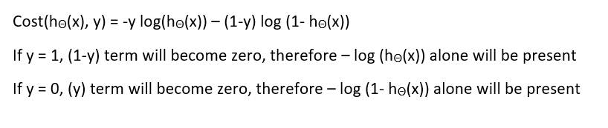

Pros and Cons:

Pros:
It is a widely used technique because it is very efficient, does not require too many computational resources, it’s highly interpretable, it doesn’t require input features to be
scaled, it doesn’t require any tuning, it’s easy to regularize, and it outputs well-calibrated predicted probabilities.
Like linear regression, logistic regression does work better when you remove attributes that are unrelated to the output variable as well as attributes that are very similar (correlated) to each other. Therefore Feature Engineering plays an important role in regards to the performance of Logistic and also Linear Regression. Another advantage of Logistic Regression is that it is incredibly easy to implement and very efficient to train. I typically start with a Logistic Regression model as a benchmark and try using more complex algorithms from there on.
Because of its simplicity and the fact that it can be implemented relatively easy and quick, Logistic Regression is also a good baseline that you can use to measure the performance of other more complex Algorithms.
Cons:
A disadvantage of it is that we can’t solve non-linear problems with logistic regression since its decision surface is linear.
In other words: You should think about using logistic regression when your Y variable takes on only two values (e.g. when you are facing a classification problem). Note that you could also use Logistic Regression for multiclass classification, which will be discussed in the next section

Multiclass Classification

Out there are algorithms that can deal by themselves with predicting multiple classes, like Random Forest classifiers or the Naive Bayes Classifier. There are also algorithms that can’t do that, like Logistic Regression, but with some tricks, you can predict multiple classes with it too. This is a classification task where our Algorithm should tell us which number is on an image.
- One-versus-All (OvA)

With this strategy, you train 10 binary classifiers, one for each number. This simply means training one classifier to detect 0s, one to detect 1s, one to detect 2s and so on. When you then want to classify an image, you just look at which classifier has the best decision score
- One-versus-One (OvO)

Here you train a binary classifier for every pair of digits. This means training a classifier that can distinguish between 0s and 1s, one that can distinguish between 0s and 2s, one that can distinguish between 1s and 2s etc. If there are N classes, you would need to train NxN(N-1)/2 classifiers, which are 45 in the case of the MNIST dataset.

1.3.2Naïve Bayes Classifier
- Naive Bayes classifier is a straightforward and powerful algorithm for the classification task. Even if we are working on a data set with millions of records with some attributes, it is suggested to try Naive Bayes approach.
- Naive Bayes classifier gives great results when we use it for textual data analysis. Such as Natural Language Processing.
- To understand the naive Bayes classifier, we need to understand the Bayes theorem. So, let’s first discuss the Bayes Theorem.

What is Bayes Theorem?
Bayes theorem named after Rev. Thomas Bayes. It works on conditional probability. Conditional probability is the probability that something will happen, given that something else has already occurred. Using the conditional probability, we can calculate the probability of an event using its prior knowledge.
Below is the formula for calculating the conditional probability.
where
- P(H) is the probability of hypothesis H being true. This is known as the prior probability.
- P(E) is the probability of the evidence (regardless of the hypothesis).
- P(E|H) is the probability of the evidence given that hypothesis is true.
- P(H|E) is the probability of the hypothesis given that the evidence is there.
- Let’s consider an example to understand how the above formula of Bayes theorem works.
Types of Naive Bayes Classifier Algorithms

Gaussian Naive Bayes
When attribute values are continuous, an assumption is made that the values associated with each class are distributed according to Gaussian i.e., Normal Distribution.
If in our data, an attribute say “x” contains continuous data. We first segment the data by the class and then compute mean & Variance of each class.
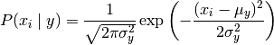

Multinomial Naive Bayes
Multinomial Naive Bayes is preferred to use on data that is multinomially distributed. It is one of the standard classic algorithms. Which is used in text categorization (classification). Each event in text classification represents the occurrence of a word in a document.

Bernoulli Naive Bayes

Bernoulli Naive Bayes is used on the data that is distributed according to multivariate Bernoulli distributions. i.e., multiple features can be there, but each one is assumed to be a binary-valued (Bernoulli, Boolean) variable. So, it requires features to be binary valued.

Pros and Cons of Naïve Bayes:

Pros:
- Naive Bayes Algorithm is a fast, highly scalable algorithm.
- Naive Bayes can be used for Binary and Multiclass classification. It provides different types of Naive Bayes Algorithms like GaussianNB, MultinomialNB, BernoulliNB.
. It is a simple algorithm that depends on doing a bunch of counts.
Great choice for Text Classification problems. It’s a popular choice for spam email classification.
- It can be easily train on small dataset

Cons-
- It considers all the features to be unrelated, so it cannot learn the relationship between features. E.g., Let’s say Remo is going to a part. While cloth selection for the party, Remo is looking at his cupboard. Remo likes to wear a white colour shirt. In Jeans, he likes to wear a brown Jeans, But Remo doesn’t like wearing a white shirt with Brown Jeans. Naive Bayes can learn individual features importance but can’t determine the relationship among features.

1.3.3 Decision Tree Algorithm
A decision tree is a flowchart-like structure in which each internal node represents a "test" on an attribute (e.g. whether a coin flip comes up heads or tails), each branch represents the outcome of the test, and each leaf node represents a class label (decision taken after computing all attributes). The paths from root to leaf represent classification rules.
In decision analysis, a decision tree and the closely related influence diagram are used as a visual and analytical decision support tool, where the expected values (or expected utility) of competing alternatives are calculated.
A decision tree consists of three types of nodes:^{[1]}
- Decision nodes – typically represented by squares
- Chance nodes – typically represented by circles
- End nodes – typically represented by triangles
Decision trees are commonly used in operations research and operations management. If, in practice, decisions have to be taken online with no recall under incomplete knowledge, a decision tree should be paralleled by a probability model as a best choice model or online selection model algorithm. Another use of decision trees is as a descriptive means for calculating conditional probabilities.
Decision trees, influence diagrams, utility functions, and other decision analysis tools and methods are taught to undergraduate students in schools of business, health economics, and public health, and are examples of operations research or management science methods.

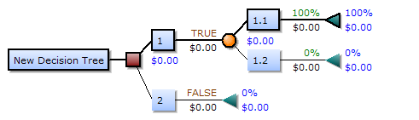
Drawn from left to right, a decision tree has only burst nodes (splitting paths) but no sink nodes (converging paths). Therefore, used manually, they can grow very big and are then often hard to draw fully by hand. Traditionally, decision trees have been created manually — as the aside example shows — although increasingly, specialized software is employed.

Decision rule
The decision tree can be linearized into decision rules,^{[2]} where the outcome is the contents of the leaf node, and the conditions along the path form a conjunction in the if clause. In general, the rules have the form:
if condition1 and condition2 and condition3 then outcome.
Decision rules can be generated by constructing association rules with the target variable on the right. They can also denote temporal or causal relations.

Decision tree using flowchart symbols
Commonly a decision tree is drawn using flowchart symbols as it is easier for many to read and understand.
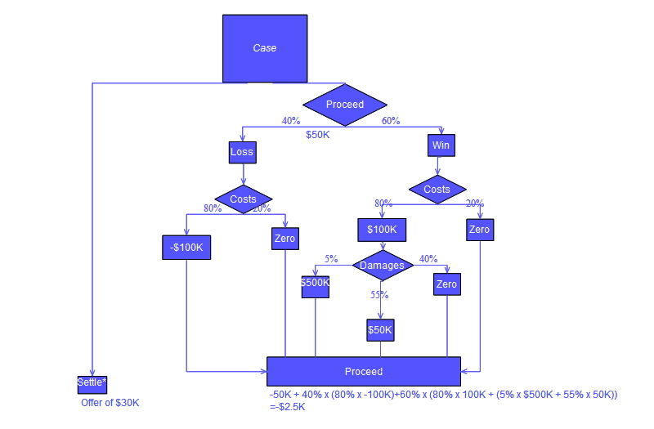

Pros and Cons:
Pros:
Among decision support tools, decision trees (and influence diagrams) have several advantages. Decision trees:
- Are simple to understand and interpret. People are able to understand decision tree models after a brief explanation.
- Have value even with little hard data. Important insights can be generated based on experts describing a situation (its alternatives, probabilities, and costs) and their preferences for outcomes.
- Help determine worst, best and expected values for different scenarios.
- Use a white box model. If a given result is provided by a model.
- Can be combined with other decision techniques.
Cons:
- They are unstable, meaning that a small change in the data can lead to a large change in the structure of the optimal decision tree.
- They are often relatively inaccurate. Many other predictors perform better with similar data. This can be remedied by replacing a single decision tree with a random forest of decision trees, but a random forest is not as easy to interpret as a single decision tree.
- For data including categorical variables with different number of levels, information gain in decision trees is biased in favor of those attributes with more levels.^{[7]}
- Calculations can get very complex, particularly if many values are uncertain and/or if many outcomes are linked.

1.3.4 K-Nearest Neighbor Algorithm (KNN):
KNN is known as an instance-based learning, or also popular as a lazy learning, where the role is only estimated locally and all calculation is postponed until classification. The k-NN algorithm is the simplest among all machine learning algorithms. It studies all existing cases and classifies into new cases based on common factor. (e.g., distance functions). Features for which it is very popular is its simplicity of interpretation and short calculation time even with such ease, it can provide greatly feasible results. The neighbors are taken from a set of objects for which the object property value (for k-NN regression) or the classes (for kNN classification) are recognized. This can be supposed of as the training set for the algorithm, though no explicit training step is essential.
- In pattern recognition, the k-nearest neighbors’ algorithm (k-NN) is a non-parametric method used for classification and regression. In both cases, the input consists of the k closest training examples in the feature space. The output depends on whether k-NN is used for classification or regression.
- In k-NN classification, the output is a class membership. An object is classified by a majority vote of its neighbors, with the object being assigned to the class most common among its k nearest neighbors (k is a positive integer, typically small). If k = 1, then the object is simply assigned to the class of that single nearest neighbor.
- In k-NN regression, the output is the property value for the object. This value is the average of the values of its k nearest neighbors.
- k-NN is a type of instance-based learning, or lazy learning, where the function is only approximated locally and all computation is deferred until classification. The k-NN algorithm is among the simplest of all machine learning algorithms.
- Both for classification and regression, a useful technique can be used to assign weight to the contributions of the neighbors, so that the nearer neighbors contribute more to the average than the more distant ones.
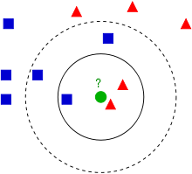
- Example of k-NN classification. The test sample (green circle) should be classified either to the first class of blue squares or to the second class of red triangles. If k = 3 (solid line circle) it is assigned to the second class because there are 2 triangles and only 1 square inside the inner circle. If k = 5 (dashed line circle) it is assigned to the first class (3 squares vs. 2 triangles inside the outer circle).
- The training examples are vectors in a multidimensional feature space, each with a class label. The training phase of the algorithm consists only of storing the feature vectors and class labels of the training samples.
- In the classification phase, k is a user-defined constant, and an unlabeled vector (a query or test point) is classified by assigning the label which is most frequent among the k training samples nearest to that query point.
- A commonly used distance metric for continuous variables is Euclidean distance. For discrete variables, such as for text classification, another metric can be used, such as the overlap metric (or Hamming distance). In the context of gene expression microarray data, for example, k-NN has also been employed with correlation coefficients such as Pearson and Spearman.
- The best choice of k depends upon the data; generally, larger values of k reduce effect of the noise on the classification, but make boundaries between classes less distinct.
- A good k can be selected by various heuristic techniques (see hyper parameter optimization). The special case where the class is predicted to be the class of the closest training sample (i.e., when k = 1) is called the nearest neighbor algorithm.
- The accuracy of the k-NN algorithm can be severely degraded by the presence of noisy or irrelevant features, or if the feature scales are not consistent with their importance

How does KNN work?
In the classification setting, the K-nearest neighbor algorithm essentially boils down to forming a majority vote between the K most similar instances to a given “unseen” observation. Similarity is defined according to a distance metric between two data points. A popular choice is the Euclidean distance given by
d(x,x′)=(x1−x′1)2+(x2−x′2)2+…+(xn−x′n)2−−−−−−−−−−−−−−−−−−−−−−−−−−−−−−−−−√d(x,x′)=(x1−x1′)2+(x2−x2′)2+…+(xn−xn′)2
but other measures can be more suitable for a given setting and include the Manhattan, Chebyshev and Hamming distance.
More formally, given a positive integer K, an unseen observation xx and a similarity metric dd, KNN classifier performs the following two steps:

It runs through the whole dataset computing dd between xx and each training observation. We’ll call the K points in the training data that are closest to xx the set AA. Note that K is usually odd to prevent tie situations.

It then estimates the conditional probability for each class, that is, the fraction of points in AA with that given class label. (Note I(x)I(x) is the indicator function which evaluates to 11 when the argument xx is true and 00otherwise)
P(y=j|X=x) =1K∑i∈AI(y(i)=j) P(y=j|X=x) =1K∑i∈AI(y(i)=j)
Finally, our input xx gets assigned to the class with the largest probability.
KNN searches the memorized training observations for the K instances that most closely resemble the new instance and assigns to it the their most common class.
An alternate way of understanding KNN is by thinking about it as calculating a decision boundary (i.e., boundaries for more than 2 classes) which is then used to classify new points.
Like most machine learning algorithms, the K in KNN is a hyper parameter that we, as a designer, must pick in order to get the best possible fit for the data set. Intuitively, we can think of K as controlling the shape of the decision boundary.
When K is small, we are restraining the region of a given prediction and forcing our classifier to be “more blind” to the overall distrib9ollution. A small value for K provides the most flexible fit, which will have low bias but high variance. Graphically, our decision boundary will be more jagged.
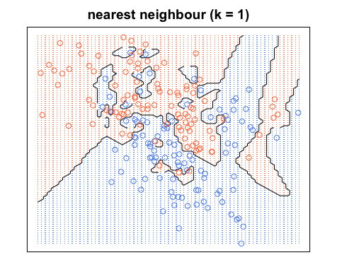
On the other hand, a higher K averages more voters in each prediction and hence is more resilient to outliers. Larger values of K will have smoother decision boundaries which mean lower variance but increased bias.
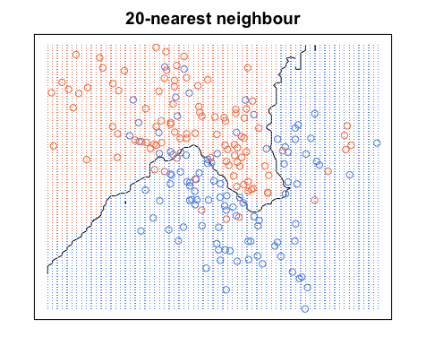
Pros and Cons of KNN
Pros
- One of the most attractive features of the K-nearest neighbor algorithm is that is simple to understand and easy to implement. With zero to little training time, it can be a useful tool for off-the-bat analysis of some data set you are planning to run more complex algorithms on. Furthermore, KNN works just as easily with multiclass data sets whereas other algorithms are hardcoded for the binary setting. Finally, as we mentioned earlier, the non-parametric nature of KNN gives it an edge in certain settings where the data may be highly “unusual”.
Cons
- One of the obvious drawbacks of the KNN algorithm is the computationally expensive testing phase which is impractical in industry settings. Note the rigid dichotomy between KNN and the more sophisticated Neural Network which has a lengthy training phase albeit a very fast testing phase. Furthermore, KNN can suffer from skewed class distributions. For example, if a certain class is very frequent in the training set, it will tend to dominate the majority voting of the new example (large number = more common). Finally, the accuracy of KNN can be. severely degraded with high-dimension data because there is little difference between the nearest and farthest neighbor

1.3.5 Support Vector Machine Algorithm
Support Vector Machines are a type of supervised machine learning algorithm that provides analysis of data for classification and regression analysis. While they can be used for regression, SVM is mostly used for classification. We carry out plotting in the n-dimensional space. The value of each feature is also the value of the specified coordinate. Then, we find the ideal hyperplane that differentiates between the two classes.
These support vectors are the coordinate representations of individual observation. It is a frontier method for segregating the two classes.
How SVM work:
The objective of the support vector machine algorithm is to find a decision boundary or hyper plane in an N-dimensional space (N — the number of features) that distinctly classifies the data points.
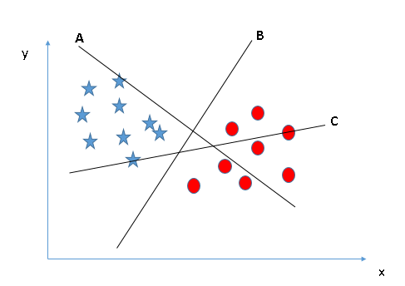

Here, we have three hyper-planes (A, B and C). Now, identify the right hyper-plane to classify star and circle.
“Select the hyper-plane which segregates the two classes better”. In this scenario, hyper-plane “B” has excellently performed this job.

A hyper plane is a line that divides the points in input variable space according to their class.., either class 0 or class 1.
In two-dimensions you can visualize this as a line.
For 3 or more dimensional space it is called as hyper plane.

What is Margin?
The distance between the nearest data points (both class) and the decision boundary (hyper plane) is called as Margin.
In svm we have to maximize distance of closest points on surface from decision boundary (hyper plane)

Here we can see that the margin for hyper plane C is high in comparison to B and C .Hence the right hyper plane is C. If we select hyper plane with low margin then there is high chance of miss-classification.

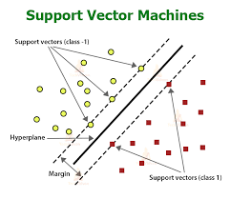

What is Support vector?
The nearest positive points and negative points passing through the marginal plane are called as support vectors. There should be minimum of 2 support vectors but can be more.
These support vectors determine the equation of hyper plane. Normally the no of support vectors is small.

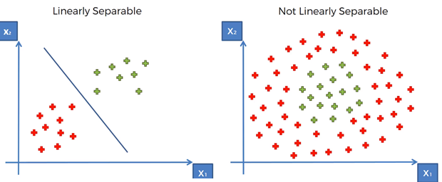

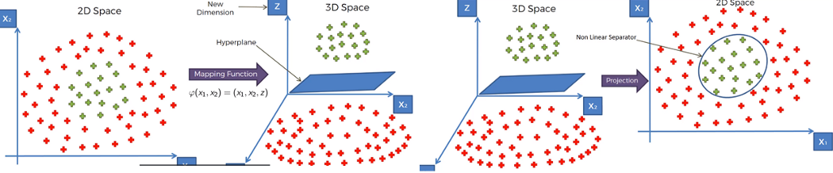

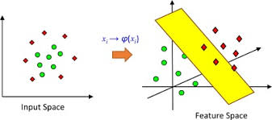
Tuning parameters for svm:
Tuning parameters are used to improve accuracy of SVM
C ---- regularization parameter
The Regularization parameter (often termed as C parameter in python’s sklearn library) tells the SVM optimization how much you want to avoid misclassifying each training example.
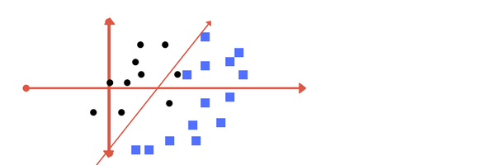
Low regularization value.
It has some misclassification due to lower regularization value.
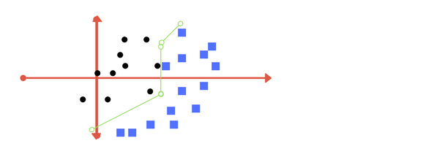
High regularization value

Kernel
SVM uses a technique called the kernel in which kernel takes a low dimensional input space and transforms it into a higher dimensional space. In simple words, kernel converts non-separable problems into separable problems by adding more dimensions to it. It makes SVM more powerful, flexible and accurate.
Gamma -
With low gamma, points far away from separation line are considered in calculation.
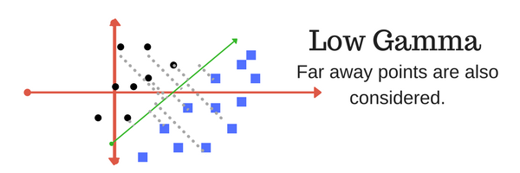
High gamma means the points close to separation line are considered in calculation.
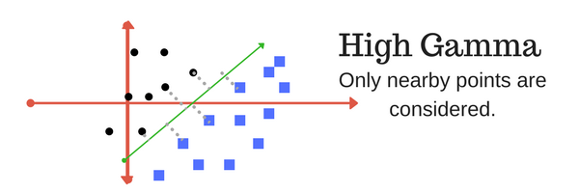

Advantages:
Works well on small and cleaner data set
Drawback:
Not suitable for larger data sets as the training time can be high.

1.3.6 Random Forest Algorithm
Random Forest classifiers are a type of ensemble learning method that is used for classification, regression and other tasks that can be performed with the help of the decision trees. These decision trees can be constructed at the training time and the output of the class can be either classification or regression. With the help of these random forests, one can correct the habit of overfitting to the training set.
Some of the advantages and disadvantages of random forest classifiers are as follows:
Advantages – Random Forest Classifiers facilitate the reduction in the over-fitting of the model and these classifiers are more accurate than the decision trees in several cases.
Disadvantages – Random forests exhibit real-time prediction but that is slow in nature. They are also difficult to implement and have a complex algorithm.

1.4 Unsupervised Learning
In the case of unsupervised learning algorithm, the data is not explicitly labeled into different classes, that is, there are no labels. The model is able to learn from the data by finding implicit patterns. Unsupervised Learning algorithms identify the data based on their densities, structures, similar segments, and other similar features. Unsupervised Learning Algorithms are based on Hebbian Learning. Cluster analysis is one of the most widely used techniques in supervised learning. Let us look at some of the important algorithms that come under Unsupervised Learning.
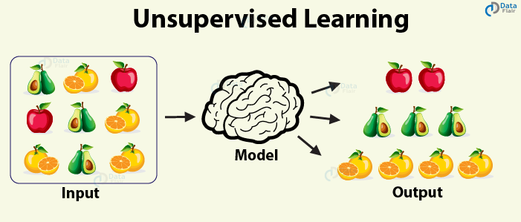

1.4.1 Clustering
Clustering, also known as cluster analysis, is a technique of grouping similar sets of objects in the same group that is different from the objects in another group. Some of the essential clustering techniques are as follows –
a. K-means
The aim of the k-means clustering algorithm is to partition the n observations in the data into k clusters such that each observation belongs to the cluster with the nearest mean. This serves as the prototype of the cluster.
b. DBSCAN
This is a clustering method that groups the data based on the density. It groups together the points that are given in the space and marks the outliers in the low-density region.
c. Hierarchical clustering
In this form of clustering, a hierarchy of clusters is built.

1.5 Reinforcement Learning
Reinforcement Learning covers more area of Artificial Intelligence which allows machines to interact with their dynamic environment in order to reach their goals. With this, machines and software agents are able to evaluate the ideal behavior in a specific context. With the help of this reward feedback, agents are able to learn the behavior and improve it in the longer run. This simple feedback reward is known as a reinforcement signal.
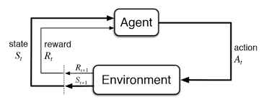
The agent in the environment is required to take actions that are based on the current state. This type of learning is different from Supervised Learning in the sense that the training data in the former has output mapping provided such that the model is capable of learning the correct answer. Whereas, in the case of reinforcement learning, there is no answer key provided to the agent when they have to perform a particular task. When there is no training dataset, it learns from its own experience.

1.6 Objective
Heart problems have gained a lot of interest in medical research because of their impact on human health where early diagnosis is critical to delaying the development of heart disease, the world's leading cause of death. thus, it is much needed to predict the possibility of occurrence of heart disease based on their attributes.
This research aims into a variety of machine learning classification algorithms for predicting heart disease using Framingham dataset.

2. Literature Survey
Current approaches To predict heart disease

1. Heart Disease Prediction Using Machine Learning and Data Mining Techniques: Application of Framingham Dataset.Turkish Journal of Computer and Mathematics Education.Vol.12 No.14(2021), 4864- 4870.Walaa Adel Mahmoud , Prof. Dr. Mohamed Aborizka ,Prof. Dr. Fathy Ahmed Elsayed Amer2

In this research work The 10-fold cross-validation resampling is used to validate the prediction model. 5 different machine learning algorithms (KNearest Neighbors,Logistic Regression,decision Tree,Random Forest and support vector machine )are used in this work. Accuracy scores of each algorithm are evaluated.
KNearestNeighbors-83.95 %
SupportVectorMachine-84.5 %
DecisionTree-84.82 %
LogisticRegression-84.89 %
RandomForest-85.05 %
The Random Forest algorithm is found to have highest accuracy.
Remark
In this approach the features are not standardized .
2. Machine Learning-Based Classification Algorithms for the Prediction of Coronary Heart Diseases.
Kelvin Kwakye & Emmanuel Dadzie
Remark
In this approach missing values are handled by mean values

3. Problem definition

3.1 Task definition
In this project the task is to predict whether a person is going to have coronary heart disease or not in upcoming 10 years by using 6 popular machine learning algorithms. These are logistic regression, K Nearest neighbours, Naïve bayes , Decision tree ,Support vector machine and random Forest algorithm. After implementing these algorithms, the best model will be found for heart disease prediction. A graphical user interface will be designed for to make prediction for new dataset.

3.2 Heart disease data set
This dataset is located at Kaggle website. The dataset contains 16 attributes in all, of which 15 are independent factors and one variable i.e., TenYearCHD is the dependent variable or target variable. This data set contains total 4240 data. All attributes in data set are numeric.
The 16 attributes that are defined here are as follows

Demographic:
- Sex: male or female (1-male and 0-female)
- Age: Age of the patient;(Continuous - Although the recorded ages have been truncated to whole numbers, the concept of age is continuous)
- Education: no further information provided

Behavioural:
- Current Smoker: whether or not the patient is a current smoker (Nominal)
- Cigs Per Day: the number of cigarettes that the person smoked on average in one day (can be considered continuous as one can have any number of cigarettes, even half a cigarette.)

Information on medical history:
- BP Meds: whether or not the patient was on blood pressure medication (Nominal)
- Prevalent Stroke: whether or not the patient had previously had a stroke (Nominal)
- Prevalent Hyp: whether or not the patient was hypertensive (Nominal)
- Diabetes: whether or not the patient had diabetes (Nominal)

Information on current medical condition:
- Tot Chol: total cholesterol level (Continuous)
- Sys BP: systolic blood pressure (Continuous)
- Dia BP: diastolic blood pressure (Continuous)
- BMI: Body Mass Index (Continuous)
- Heart Rate: heart rate (Continuous - In medical research, variables such as heart rate though in fact discrete, yet are considered continuous because of large number of possible values.)
- Glucose: glucose level (Continuous)

Target variable to predict:
- 10year risk of coronary heart disease (CHD) - (binary: “1”, means “Yes”, “0” means “No”)

Attribute & description
Age | (32-70)
Sex | 0=Female, 1=Male
Education | It takes values as:  1=High School,  2=High School or GED,  3=College or Vocational School, 4=College
Current Smoker | 0=No  1=Yes
Cigs Per Day | Number of Cigarettes smoked Per Day (0-70)
BP Meds | 0=No  1=Yes
Prevalent Stroke | 0=No  1=Yes
Prevalent Hyp | 0=No  1=Yes
Diabetes | 0=No  1=Yes
Tot Chol | Serum Cholesterol (107-696) (mg/dl)
Sys BP | (83.5-295) (mm/hg)
Día BP | (48-142.5) (mm/hg)
Body Mass  Index | (15.54-56.8)
Heart Rate | Heart Rate achieved (44-143)
Glucose | (40-394) (mg/dl)
10-year CHD | 0=Healthy, 1=Diseases

4. Experimental set up and evaluation
Python:
Python is an interpreted, high-level, general-purpose programming language. Created by Guido van Rossum and first released in 1991, Python has a design philosophy that emphasizes code readability, notably using significant whitespace. It provides constructs that enable clear programming on both small and large scales. In July 2018, Van Rossum stepped down as the leader in the language community.
Python features a dynamic type system and automatic management. It supports multiple programming paradigms, including object-oriented, imperative, functional and procedural, and has a large and comprehensive standard library.^{[29]}
Python interpreters are available for many operating systems. C Python, the reference implementation of Python, is open source software and has a community-based development model, as do nearly all of Python's other implementations. Python and C Python are managed by the non-profit Python Software Foundation.
Here, we have used Python 3.8 as it is the stable version as on now.
Python Packages:
They are simply directories, but with a twist. Each package in Python is a directory which MUST contain a special file called __init__.py. This file can be empty, and it indicates that the directory it contains is a Python package, so it can be imported the same way a module can be imported.
Packages are a way of structuring Python’s module namespace by using "dotted module names". A.B stands for a sub module named B in a package named A. Two different packages like P1 and P2 can both have modules with the same name, let's say A, for example. The sub module A of the package P1 and the sub module A of the package P2 can be totally different. A package is imported like a "normal" module.

4.1 Components to be installed:
Anaconda (python 3.9)
Python Packages to be installed
- pandas- used to provide fast, flexible and expressive data structures to make working with “relational” or “labeled” data both easy and intuitive.
- numpy: To work with arrays
- tkinter- used for developing Graphical User Interface (GUI).
- sklearn- efficient for data mining and data analysis. It contains a number of algorithms which can be implemented directly when required.
- matplotlib- contains modules which are used for plotting graphs.
- Seaborn – used for Graphical Presentation

4.2 Methodology

Data preprocessing
- Remove unnecessary columns
- handle missing values and outliers
Raw dataset

Exploratory Data Analysis

Split data set
Testing (20%)
Training (80%)

PERFORMANCE EVALUATION
Accuracy and F1 Score
Algorithms
- LR
- KNN
- DT
- SVM
- NB
- RF

Best Algorithm

Make Prediction

4.2.1Data Preprocessing
Data preprocessing is a group of techniques that are applied on the data to improve the quality of the data. Raw data can be converted to useful data. It uses various techniques such as handling missing values, detecting outliers, removing un wanted attributes etc.
Once data is cleaned then it can be used in machine learning models for training. Data preprocessing is one of the most important steps involved in predictive modelling.
Steps followed in data preprocessing
- Education column is removed as it has no relation with heart disease
- Most corelated features are found by using correlation matrix(heatmap).
Sysbp and Diabp are highly corelated
Current smoker and Cigsperday are highly corelated.so only one of them is selected.
- Missing values are handled by imputation .
- Outliers found and removed.
- Duplicated rows removed.
- Features have been standardized by using Standard Scaler .

4.2.2Explarotery analysis
Exploratory Data Analysis (EDA) is an approach to analyse the data using visual techniques. It is used to discover trends, patterns, or to check assumptions with the help of statistical summary and graphical representations.
Corelation Matrix :
Corelation Matrix is used to show the relationship among the features. It is shown by heatmap
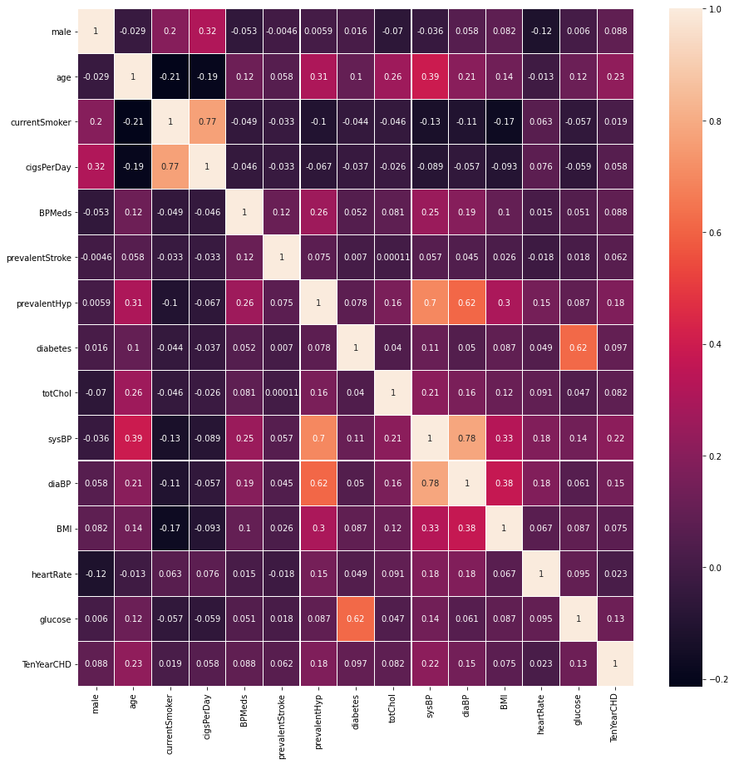
(Heat Map)
Bar Chart showing Number of People Suffer From heart disease:
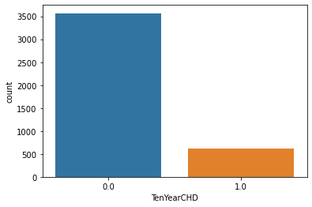

Pie Chart showning percentage of people with and wit out heart disease
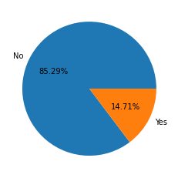
Pie chart showing male and female percentage
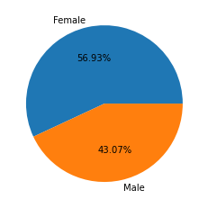

Male and Female having disease or not
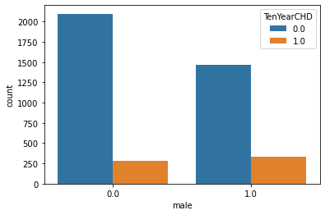
4.2.3 Splitting dataset
Data set is splitted into training and testing subsets .
For training 80% data and for testing 20% of data is selected .
4.2.3 Algorithms
For building machine learning model following algorithms
Are used.
A.KNearest Neighbors
B.Logistic Regression
C.Decision Tree
D.Naive Bayes
E.Support Vector Machine
F.Random Forest

4.2.4 Performance Evaluation Criteria

Commonly, the performance of ML prediction systems is frequently assessed using metrics based on the classification algorithm. The accuracy, confusion matrix, and F-measure are used to evaluate the prediction findings in this research.

Confusion Matrix
A confusion matrix is used to evaluate algorithms in ML. A matrix for a binary classification problem is a square of two by two as illustrated in following Table , where the column represents the algorithm's prediction and the row reflects the real value of the class label, where true-positive (TP) is numerous positive samples accurately predicted. False-negative (FN) refers to numerous positive samples that were anticipated incorrectly. False- positive (FP) refers to a situation in which numerous negative samples are incorrectly classified as positive. A true-negative (TN) is a collection of negative samples that have been accurately anticipated .

Actual | Predict
Actual | Positive | Negative
Positive | TP | FP
Negative | FN | TN

5.GUI Implementation
A GUI is developed in python by using tkinter package to generate a simple interface which takes input for all the values necessary for evaluation. After the input is taken from the user, prompt appears which decides whether a person has a presence of heart disease or not.

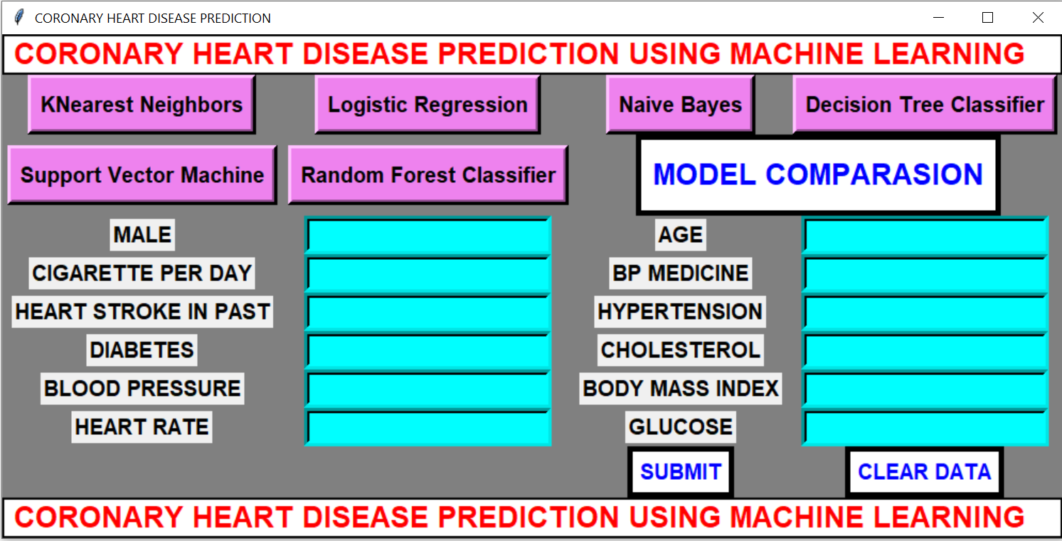

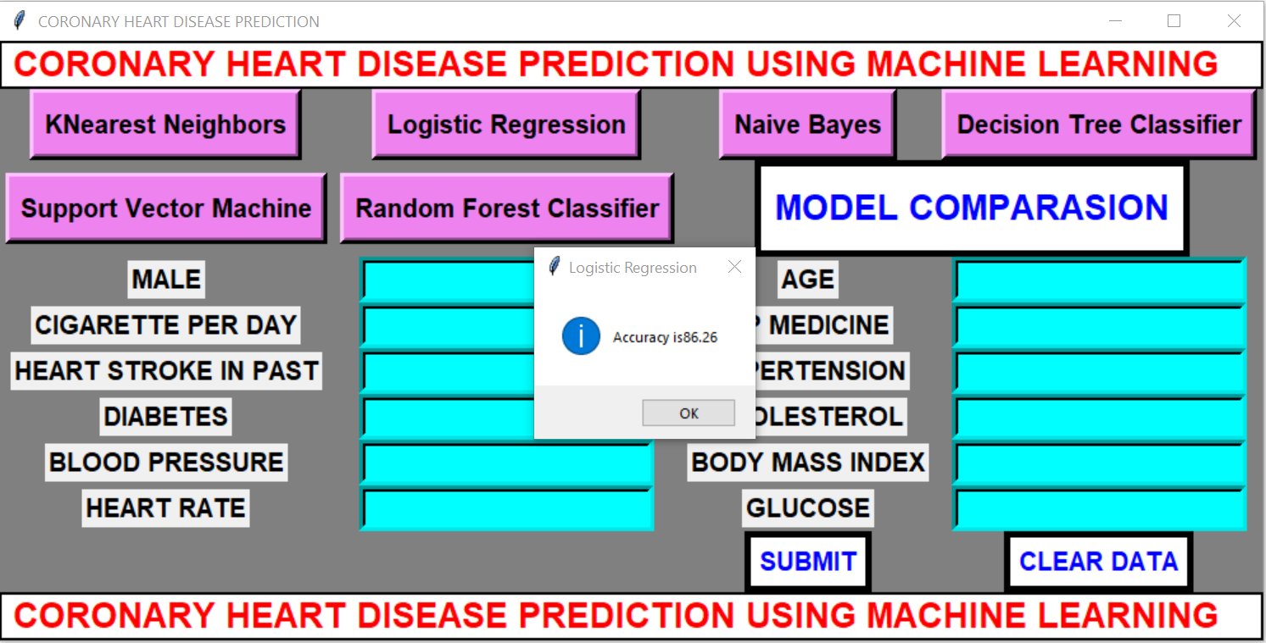
Accuracy of Logistic Regression

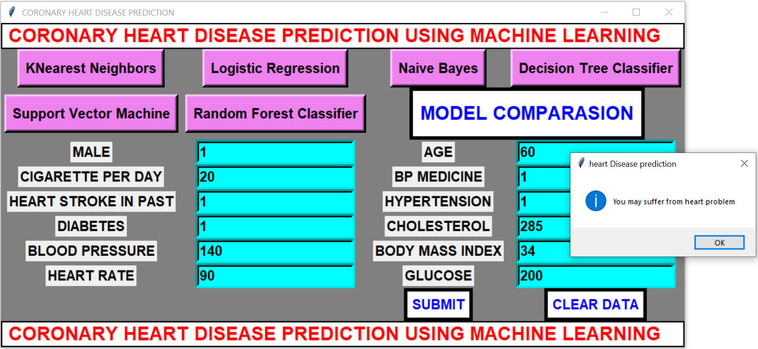

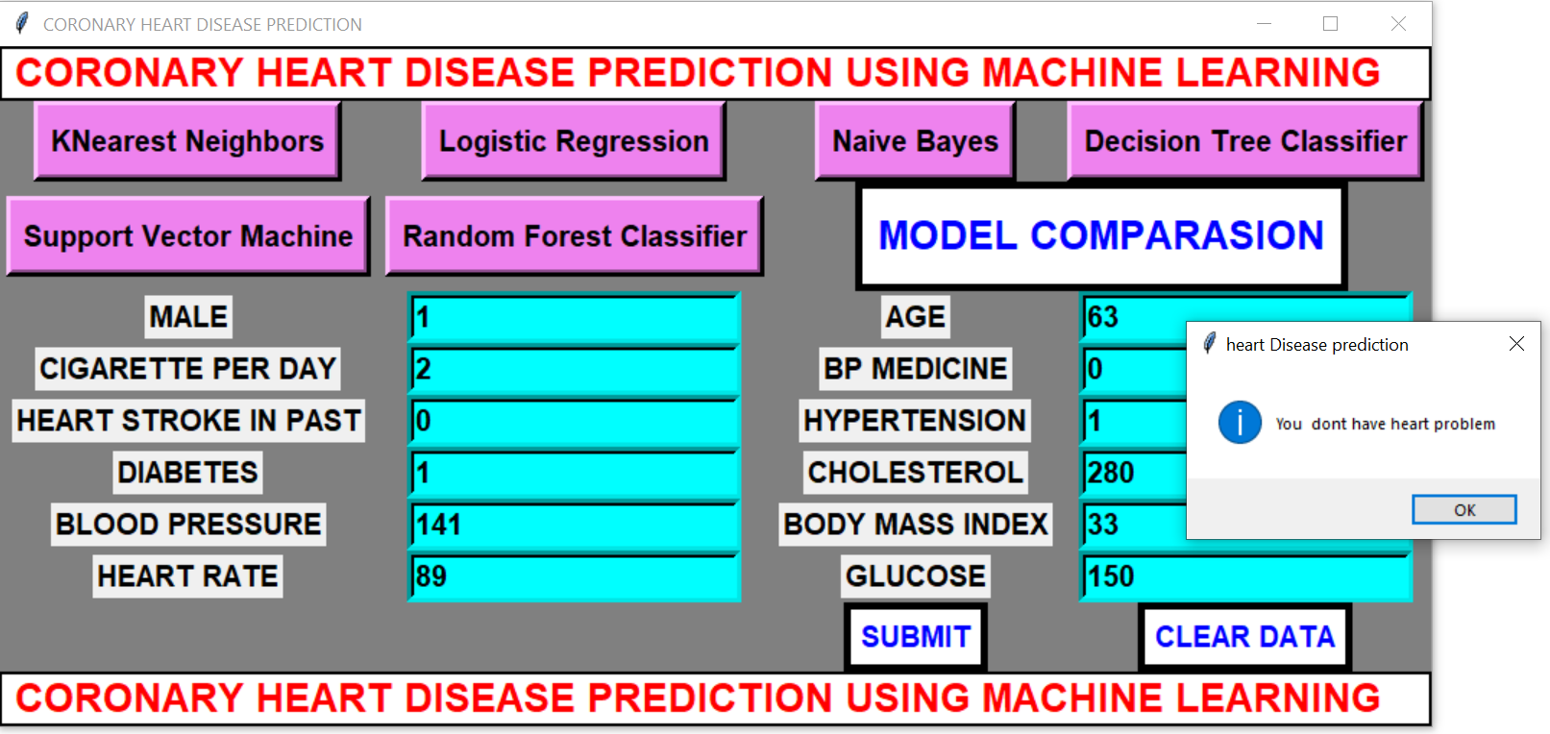

6. conclusion
- In this project six different machine learning algorithms are applied for prediction of heart disease.
- They are Logistic Regression, K-nearest Neighbours, Naïve Bayes, Decision Tree, Random Forest and SVM .
- Accuracy of Logistic Regression is 86.26%, K-nearest Neighbours is 85.42%, Naïve Bayes is 83.63%, Decision Tree is 83.03%, Random forest is 86.14% and SVM is 85.9%.
- From the above we conclude that Logistic Regression is the best model for coronary heart disease prediction.

7. Future Work
- In this project 6 machine learning algorithms are applied for prediction of coronary heart disease .It was found that Logistic Regression performs better than other algorithms. Also a GUI is developed for prediction of heart disease. In future artificial neural networks algorithms will be used to get better accuracy. Also a web based system will be developed so that people from different parts of world can use it.

8.Reference

Heart Disease Prediction Using Machine Learning and Data Mining Techniques: Application of Framingham Dataset.Turkish Journal of Computer and Mathematics Education.Vol.12 No.14(2021), 4864- 4870.Walaa Adel Mahmoud , Prof. Dr. Mohamed Aborizka ,Prof. Dr. Fathy Ahmed Elsayed Amer2 .

- J. S. Sonawane and D. R. Patil, ”Prediction of heart disease using multilayer perceptron neural network,” International Conference on Information Communication and Embedded Systems (ICICES2014), pp. 1–6, Feb, 2014. doi: 10.1109/ICICES.2014.7033860.
- S. A. Pattekari and A. Parveen, ”Prediction system for heart disease using Naive Bayes,” International Journal of Advanced Computer and Mathematical Sciences, vol. 3, no. 3, pp. 290–294, 2012.
- K. H. Miao, J. H. Miao, and G. J. Miao, ”Diagnosing Coronary Heart Disease Using Ensemble Machine Learning,” (IJACSA) International Journal of Advanced Computer Science and Applications, vol. 7, no. 10, pp. 30–39, 2016. doi: 10.14569/IJACSA.2016.071004.
- K. H. Miao and J. H. Miao, ”Coronary Heart Disease Diagnosis using Deep Neural Networks,” (IJACSA) International Journal of Advanced Computer Science and Applications, vol. 9, no. 10, pp. 1-8, 2018. doi: 10.14569/IJACSA.2018.091001.
- R. Das, I. Turkoglu, and A. Sengur, ”Effective diagnosis of heart disease through neural networks ensembles,” Expert Systems with Applications, vol. 36, no. 4, pp. 7675–7680, May, 2009. doi: https://doi.org/10.1016/j.eswa.2008.09.013.
- S. Bashir, U. Qamar, F. H. Khan, and M. Y. Javed, ”An Efficient Rule- Based Classification of Diabetes Using ID3, C4.5, & CART Ensem- bles,” in 2014 12th International Conference on Frontiers of Information Technology, pp. 226–231, Dec 2014. doi: 10.1109/FIT.2014.50.
- T. Panch, P. Szolovits, and R. Atun, ”Artificial intelligence, machine learning and health systems,” Journal of Global Health, vol. 8, Decem- ber. 2018. doi: doi: 10.7189/jogh.08.020303.
- G. D. Magoulas and A. Prentza, ”Machine Learning in Medical Applica- tions,” Machine Learning and Its Applications, vol. 2049, pp. 300–307, 2001. doi: https://doi.org/10.1007/3-540-44673-7 19

- S. A. Alasadi and W. Bhaya , ”Review of data preprocessing techniques in data mining,” Journal of Engineering and Applied Sciences, vol. 12, no. 16, pp. 4102–4107, Sep 2017.
- A. Gupta and V. Khathuria,” Framingham heart study,” International Journal on Future Revolution in Computer Science & Communication Engineering, vol. 4, no. 11, pp. 55–58, 2018.
- K.V. Nagendra and M. Ussenaiah, ”Analysis of classification algorithms on heart diseases data using association rule mining, ” International Journal of Computational Engineering Research(IJCER), vol. 08, no. 6, pp. 39–46, 2018.
- K. V. Nagendra and M. Ussenaiah, ”Support vector machine and neural network classification improved by bagging,” International Journal on Future Revolution in Computer Science & Communication Engineering, vol. 4, no. 2, pp. 125–130, 2018.
- J. Beunza, E. Puertas, E. Garc´ıa-Ovejero, G. Villalba, E. Condes,
G. Condes, and M. F. Landecho ”Comparison of machine learning algorithms for clinical event prediction(risk of coronary heart disease),” Journal of Biomedical Informatics, vol. 97, p. 103257, Sep.2017. doi:https://doi.org/10.1016/j.jbi.2019.103257.
- A. S. T. Nishadi, ”Predicting heart diseases in logistic regression of machine learning algorithms by python jupyterlab, ” International Journal of Advanced Research and Publications, vol. 3,no. 8, pp. 69–74, Aug 2019.
- A. Bhardwaj, A. Kundra, B. Gandhi, S. Kumar, A. Rehalia, and
M. Gupta, ”Prediction of heart attack using machine learning,” IITM Journal of Management and IT, vol. 10, no. 1, pp. 20–24, 2019.
- A. Valle, A. Cinaud, V. Blachier, H. Lelong, M. E. Safar, and J. Blacher ”Coronary heart disease diagnosis by artificial neural networks including aortic pulse wave velocity index and clinical parameters,” Journal of Hypertension, vol. 37, no. 8, pp. 1682–1688, Aug. 2019. doi:10.1097/HJH.0000000000002075.
- K. Lim, B. M. Lee, U. Kang, and Y. Lee ”An optimized DBN- based coronary heart disease risk prediction,” International Journal of Computers Communications & Control, vol. 13,no. 4, pp. 492–502, Jul 2018. doi: https://doi.org/10.15837/ijccc.2018.4.3269 .
- J.K. Kim and S. Kang, ”Neural network-based coronary heart disease risk prediction using feature correlation analysis, ” Jour- nal of Healthcare Engineering, vol. 2017, pp. 1–13, 2017. doi: https://doi.org/10.1155/2017/2780501.
- N.S. Rajliwall, G. Chetty, and R. Davey, ”Chronic disease risk moni- toring based on an innovative predictive modelling framework,” 2017 IEEE Symposium Series on Computational Intelligence (SSCI), pp. 1–8, 2017. doi: 10.1109/SSCI.2017.8285257, 1-8, 2017.
- N. S. Rajliwall, R. Davey, and G. Chetty, ”Machine learning based mod- els for cardiovascular risk prediction,” 2018 International Conference on Machine Learning and Data Engineering(iCMLDE), pp. 142–148, 2018. doi: 10.1109/iCMLDE.2018.00034, 142– 148, 2018.
- I. D. Mienye, Y. Sun, and Z Wang, ”Improved sparse autoencoder based artificial neural network approach for prediction of heart disease,”, Informatics in Medicine Unlocked, vol. 18, 100307, 2020.
- P. Puvar, N. Patel, A. Shah, R. Solanki, and D. Rana, ”Heart Disease Detection using Ensemble Learning Approach,” International Research Journal of Engineering and Technology (IRJET), vol. 8, no. 5, pp. 1414- 1418, May, 2021.
- N. K. Sharma, M. Vemula, and V. Tadiboyina, ”An Experimental Study of Heart Disease Prediction Using Different Supervised Machine Learning Algorithms”, International Journal of Engineering Research and Technology, vol. 14, no. 3, pp. 227-240, 2021.
- H. A. G. Elsayed and L. Syed, ”An automatic early risk classification of hard coronary heart diseases using framingham scoring model,” in Proceedings of the Second International Conference on Internet of things, Data and Cloud Computing. ACM, pp. 1-8, Mar 2017. doi: https://doi.org/10.1145/3018896.3036384
- P. Jonsson and C. Wohlin, ”An evaluation of k-nearest neighbour impu- tation using likertdata,” 10th International Symposium on Software Met- rics, 2004. Proceedings.IEEE, pp. 108-118, 2004. doi: 10.1109/MET- RIC.2004.1357895.
- G. Aksu, C. O. Gu¨zeller, and M.T Eser, ”The Effect of the Nor- malization Method Used in Different Sample Sizes on the Success of Artificial Neural Network Model”, International Journal of Assess- ment Tools in Education, vol. 6, no. 2, , pp. 170–192, 2019. doi: https://doi.org/10.21449/ijate.479404.
- S. Prasad, ”Some notes on z- scores and t- scores,” International Journal of scientific research and management (IJSRM), vol. 3, no. 4, pp. 2608- 2610, 2015.
- K. Potdar, T. S. pardawala, and C. D. pai, ”A comparative study of categorical variable encoding techniques for neural network classifiers,” International Journal of Computer Applications, vol. 175 ,no.4, pp. 7–9, Oct, 2017.
- H. LIU, F. Hussain, C. L.TAN, and M. DASH, ”Discretization: An Enabling Technique,” Data Mining and Knowledge Discovery, vol.6, pp. 393–423, 2002. doi: https://doi.org/10.1023/A:1016304305535.
- D. Ramesh, P. Suraj, and L. Saini, ”Big data analytics in healthcare: A survey approach,” in 2016 International Conference on Microelec- tronics, Computing and Communications (Mi-croCom), pp. 1–6, Jan, 2016.
- C. B. C. Latha and S. C. Jeeva, ”Improving the accuracy of prediction of heart disease risk based on ensemble classification techniques,” Informatics in Medicine Unlocked, vol. 16, p.100203, 2019. doi: https://doi.org/10.1016/j.imu.2019.100203.
- A. H. Khaleel, G. A. Al-Suhail, and B. M. Hussan, ”A weighted voting of k-nearest neighbor algorithm for diabetes mellitus,” International Journal of Computer Science and Mobile Computing, vol. 6, no. 1, pp. 43–51, 2017.
- N. Ali, D. Neagu, and P. Trundle, ”Evaluation of k-nearest neighbour classifier performance for heterogeneous data sets,” SN Applied Sci- ences, vol 1, no. 12, Nov, 2019.
- Y. Zhang, Z. Lin, Y. Kang, R. Ning, and Y. Meng, ”A feed-forward neural network model for the accurate prediction of diabetes mellitus,” INTERNATIONAL JOURNAL OF SCIENTIFIC & TECHNOLOGY RESEARCH, vol.7, no.8, pp. 151–155, Aug, 2018.
- H. Yan, et al., ”A multilayer perceptron-based medical decision support system for heart disease diagnosis,” Expert Systems with Applications, vol.30, no.2, pp. 272 – 281, 2006.

